### Current Activities

The first couple of months this year were relatively quiet, with 3 curators taking vacation, two of who got stranded in Oz and NZ during March. Hursley closed for the duration at the beginning of March, with employees working from home, so we’ve not been back there since. Activities have been limited to web site updates and thoughts for the future.

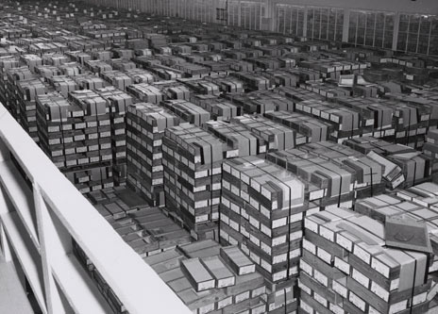A new page has been added to the web site, which tries to explain the typical processes and hardware involved in data processing using punch cards. <https://slx-online.biz/hursley/pcprocess.asp> . It also highlights some of the hardware that in part contributed to the demise of the IBM Card. It includes a photo of a warehouse facility containing an estimated 4Gb of punch card storage. Each punch card offered a maximum of 80 columns, or bytes. One card box typically contained 2,000 cards for a maximum of 160K bytes, 6.1/4 boxes per Megabyte, or 625 boxes per 100M. Find your little processing job amongst that lot!

We had an unusual enquiry from a lady in Ireland, whose father used to run a typewriter rental business. Her parents gave her the middle name “Pifont” after a Selectric typewriter golf ball that contained the Pi symbol, and she in turn has given her daughter that middle name. She wanted to show her daughter a picture of the golf ball and wondered if we could help. After digging through our collection I managed to find one such type-head and was able to send her a photo and a print-out of the complete Symbol font set.

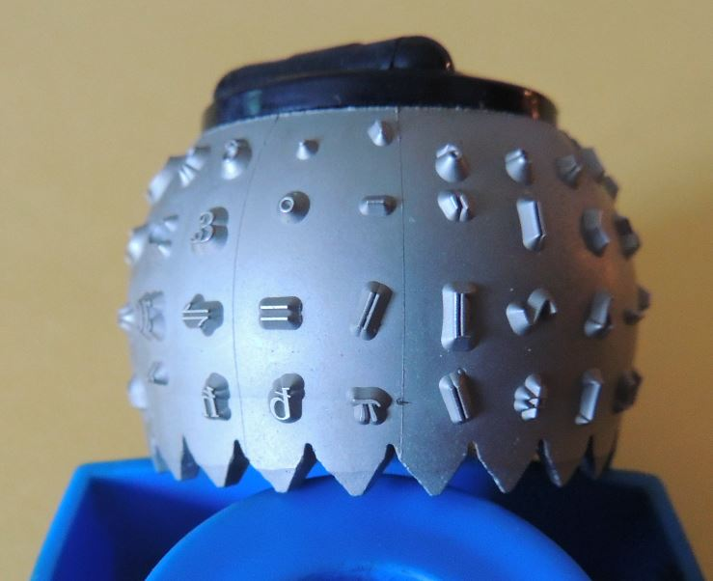 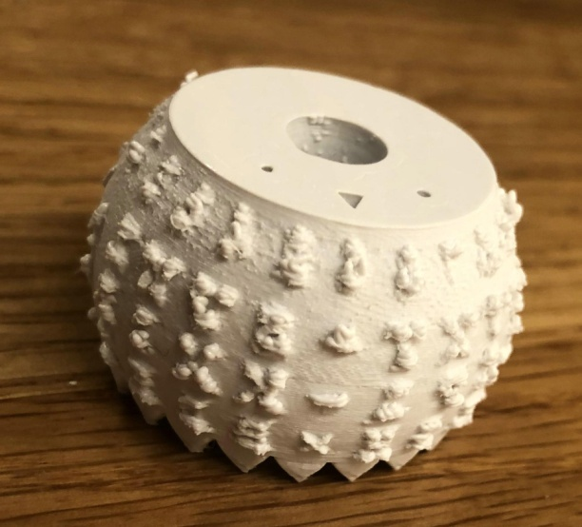

The follow on plan was to see if we had a duplicate type head which we could send, but the dreaded virus thwarted that plan. Meanwhile we found a 3D printer file which I was able to update with a Greek font. My son ran this through his 3D printer, but as expected the quality was nowhere near good enough. We do have access to a resin printer in Hursley, so some day we should be able to produce this in a much higher quality and surprise Ms.Pifont.

### Trifolds

Another new trifold has been added to the collection, the first of a series covering IBM innovation that helped to change the world. It is now available on the museum web site trifold page at <https://slx-online.biz/hursley/trifolds.asp> .

### Other

Last time I reported on the offer of a working System/3. The owner subsequently informed us that he’s not yet ready to part with it, and we may have to wait for illness or his demise. At least that gives us time to try and find £5K for shipping charges. We live in hope!

We’ve also added a link from the museum web site to IBM’s interactive “History of Progress” at <https://www.ibm.com/ibm/history/interactive/index.html> . This runs in your browser, windowed or full screen, using Adobe Flash Player, and gives a really interesting account of IBM’s history from pre-IBM 1890s through to the early 2000s.There’s also a desktop version and a PDF of the story to download.